Computing and software are changing the jobs of the future.
Students with skills have more options than those without.
Computer Science is relevant to EVERY college major.

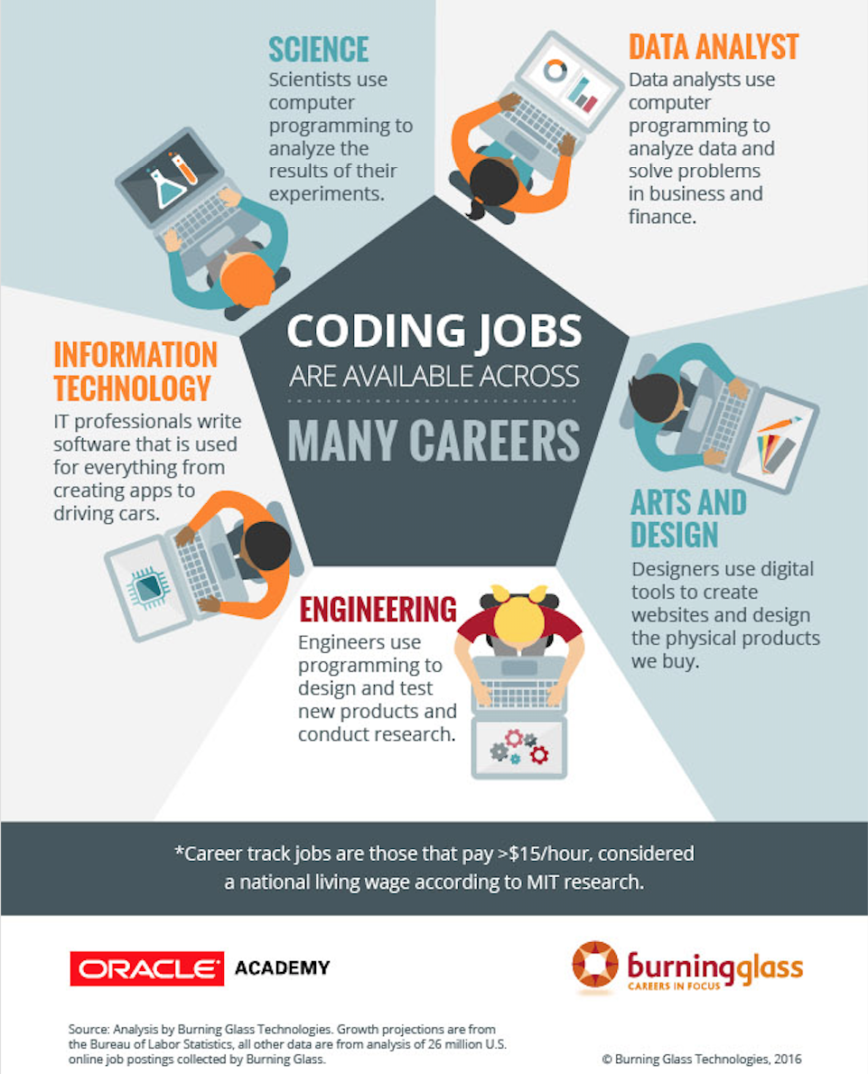
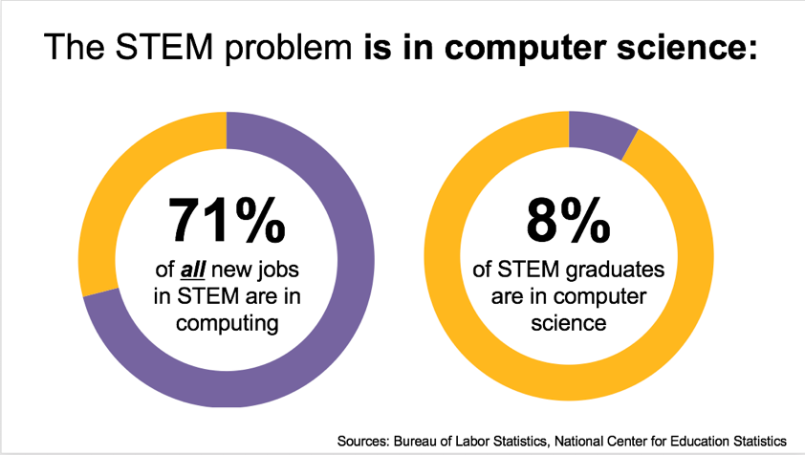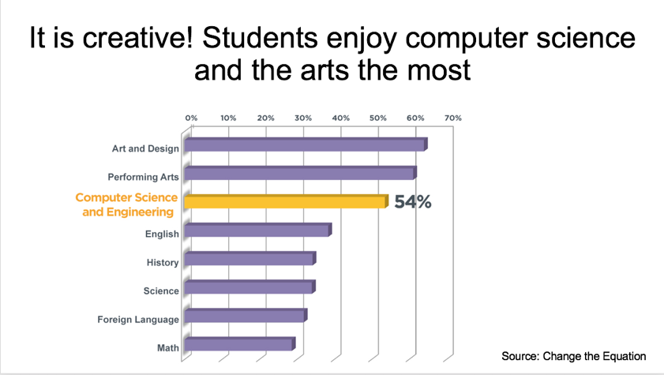

Computers and software are changing everything!

Computer Science is the one AP class every college bound student should take.
It’s challenging and it’s creative.
It’s practical because over time more and more jobs require computer skills

- AP Computer Science Principles
  - AP Computer Science Principles offers a multidisciplinary approach to teaching the underlying principles of computation. The course will introduce students to the creative aspects of programming, abstractions, algorithms, large data sets, the Internet, cybersecurity concerns, and computing impacts.
  - Designed for general education students.
  - Can count as a tech credit.

- AP Computer Science A – Java programming
  - AP Computer Science A introduces students to computer science with fundamental topics that include problem solving, design strategies, and methodologies, organization of data (data structures), approaches to preocessing data (algorithms), analysis of potential solutions, and the ethical and social implications of computing. The course emphasizes both object-oriented and impertive design to develop solutions that can scale up from small, simple programs to large, complex problems..
  - Requires some knowledge of programming. Equivalent to a 1st semester CS major course.

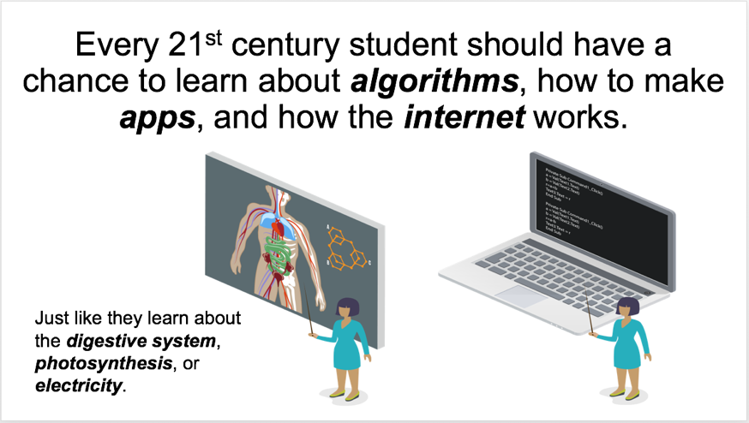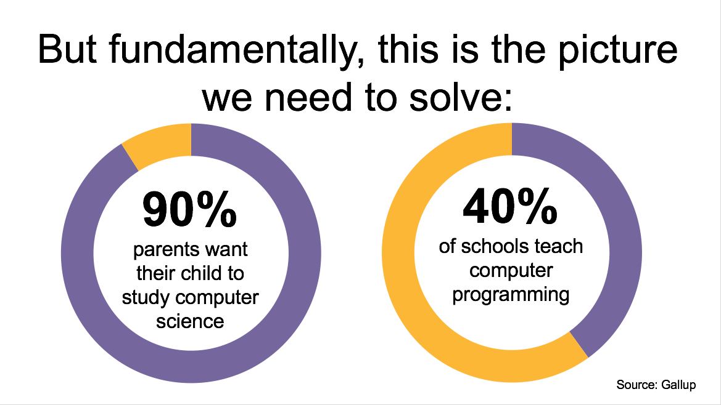
from Code.org and the College Board

